Database Soal Matematika 1 AIK21310

**DAFTAR ISI**

DAFTAR ISI ............................................................................................................................................................... 1 UJIAN TENGAH SEMESTER 2007/2008 ......................................................................................................... 3 UJIAN TENGAH SEMESTER 2009/2010 .......................................................................................................... 4 UJIAN AKHIR SEMESTER 2008/2009 .............................................................................................................. 5 UJIAN AKHIR SEMESTER 2009/2010 R1 ....................................................................................................... 6 UJIANAKHIR SEMESTER 2009/2010 R2 ................................................................................................... 7 UJIAN TENGAH SEMESTER 2010/2011 ......................................................................................................... 8 UJIAN AKHIR SEMESTER 2010/2011 .............................................................................................................. 9 UJIAN AKHIRSEMESTER 2011/2012 ...................................................................................................... 11 UJIAN TENGAH SEMESTER 2012/2013 .................................................................................................. 12 UJIAN AKHIR SEMESTER 2012/2013 ....................................................................................................... 13 UJIAN AKHIR SEMESTER 2013/2014 ...................................................................................................... 14 UJIAN TENGAH SEMESTER 2014/2015 .................................................................................................. 15 UJIAN AKHIR SEMESTER 2014/2015 ...................................................................................................... 16 UJIAN TENGAH SEMESTER 2015/2016 .................................................................................................. 17 UJIAN AKHIR SEMESTER 2015/2016 ...................................................................................................... 18 UJIAN TENGAH SEMESTER 2016/2017 ...................................................................................................................... 19 UJIAN AKHIR SEMESTER 2016/2017 .......................................................................................................................... 20 UJIAN AKHIR SEMESTER 2017/2018 .......................................................................................................................... 21 UJIANAKHIRSEMESTER2018/2019 ........................................................................................................................... 22 UJIAN TENGAH SEMESTER 2019/2020 ..................................................................................................................... 24 UJIAN AKHIR SEMESTER 2019/2020 .......................................................................................................................... 25

DIKLAT HMIF Page 2

Database Soal Matematika 1 AIK21310 **UJIAN TENGAH SEMESTER 2007/2008**

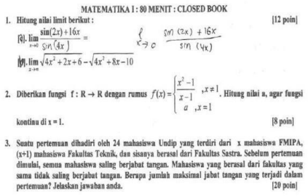DIKLAT HMIF Page 3

Database Soal Matematika 1 AIK21310 **UJIAN TENGAH SEMESTER2009/2010**

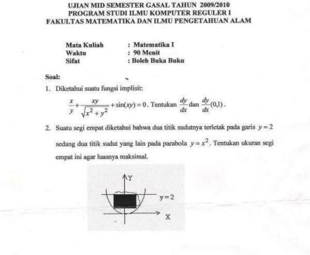DIKLAT HMIF Page 4

Database Soal Matematika 1 AIK21310 **UJIAN AKHIR SEMESTER2008/2009**

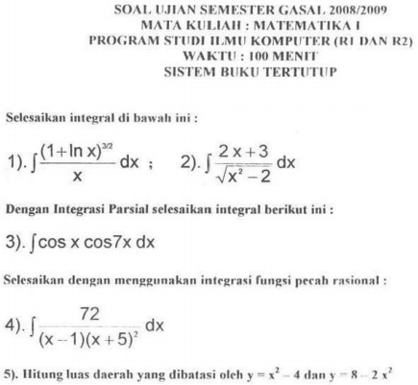DIKLAT HMIF Page 5

Database Soal Matematika 1 AIK21310

**UJIAN AKHIR SEMESTER 2009/2010 R1**

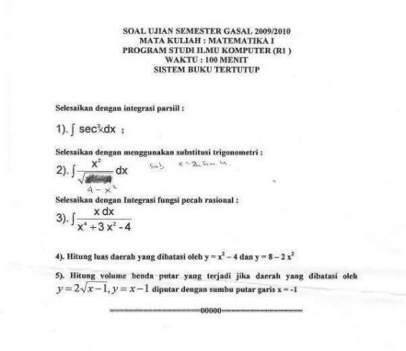DIKLAT HMIF Page 6

Database Soal Matematika 1 AIK21310

**UJIAN AKHIR SEMESTER 2009/2010 R2**

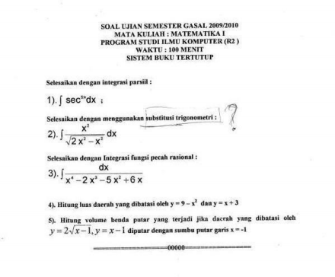DIKLAT HMIF Page 7

Database Soal Matematika 1 AIK21310 **UJIAN TENGAH SEMESTER 2010/2011**

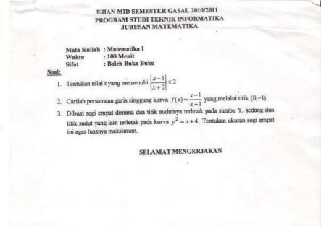DIKLAT HMIF Page 8

Database Soal Matematika 1 AIK21310

**UJIAN AKHIR SEMESTER 2010/2011**

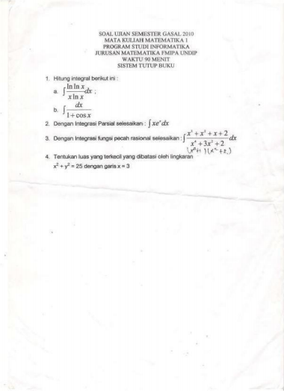DIKLAT HMIF Page 9

Database Soal Matematika 1 AIK21310 **UJIAN AKHIR SEMESTER 2011/2012**

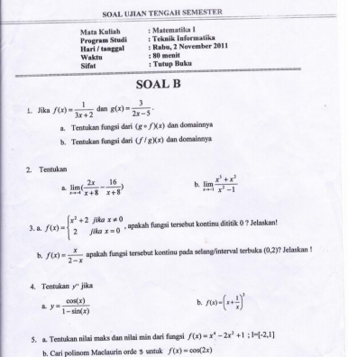DIKLAT HMIF Page 10

Database Soal Matematika 1 AIK21310

**UJIAN AKHIR SEMESTER 2011/2012**

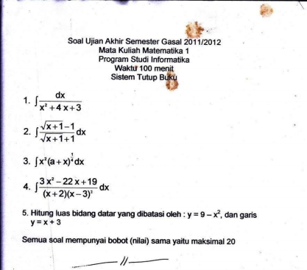DIKLAT HMIF Page 11

Database Soal Matematika 1 AIK21310

**UJIAN TENGAH SEMESTER 2012/2013**

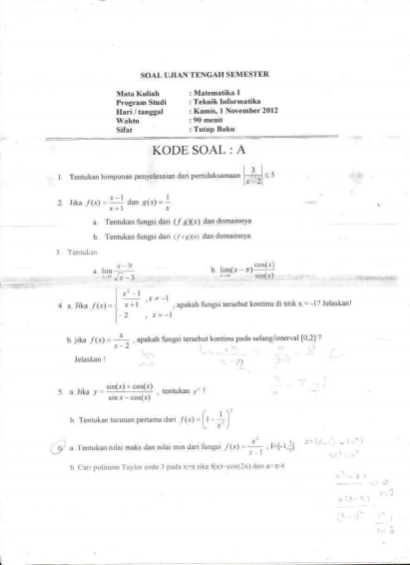DIKLAT HMIF Page 12

Database Soal Matematika 1 AIK21310 **UJIAN AKHIR SEMESTER 2012/2013**

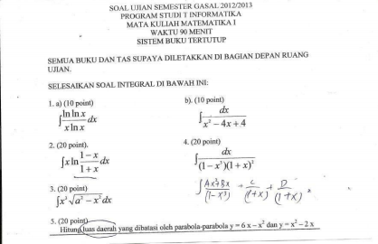DIKLAT HMIF Page 13

Database Soal Matematika 1 AIK21310

**UJIAN AKHIR SEMESTER 2013/2014**

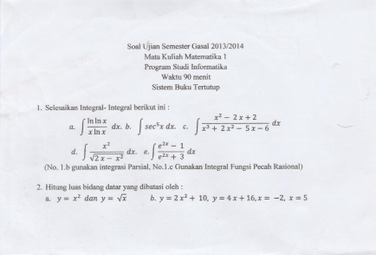DIKLAT HMIF Page 14

Database Soal Matematika 1 AIK21310 **UJIAN TENGAH SEMESTER 2014/2015**

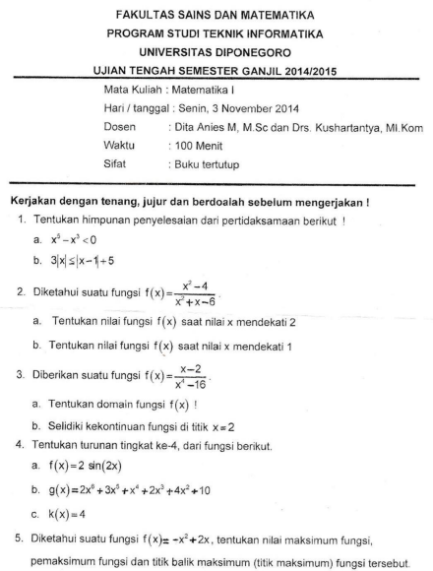DIKLAT HMIF Page 15

Database Soal Matematika 1 AIK21310 **UJIAN AKHIR SEMESTER 2014/2015**

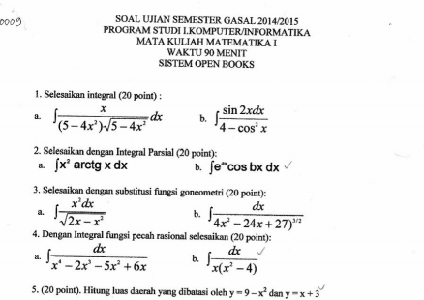DIKLAT HMIF Page 16

Database Soal Matematika 1 AIK21310

**UJIAN TENGAH SEMESTER 2015/2016**

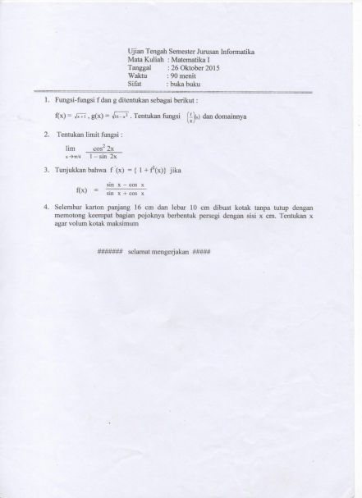DIKLAT HMIF Page 17

Database Soal Matematika 1 AIK21310

**UJIAN AKHIR SEMESTER 2015/2016**

****DIKLAT HMIF Page 18

Database Soal Matematika 1 AIK21310 **UJIAN TENGAH SEMESTER 2016/2017**

****DIKLAT HMIF Page 19

Database Soal Matematika 1 AIK21310

**UJIAN AKHIR SEMESTER 2016/2017**

****DIKLAT HMIF Page 20

Database Soal Matematika 1 AIK21310 **UJIAN AKHIR SEMESTER 2017/2018**

****DIKLAT HMIF Page 21

Database Soal Matematika 1 AIK21310

**UJIAN TENGAH SEMESTER 2018/2019**

****DIKLAT HMIF Page 22

Database Soal Matematika 1 AIK21310 **UJIAN AKHIR SEMESTER 2018/2019**

****DIKLAT HMIF Page 23

Database Soal Matematika 1 AIK21310

**UJIAN TENGAH SEMESTER 2019/2020**

DIKLAT HMIF Page 24

Database Soal Matematika 1 AIK21310

**UJIAN AKHIR SEMESTER 2019/2020**

DIKLAT HMIF Page 25